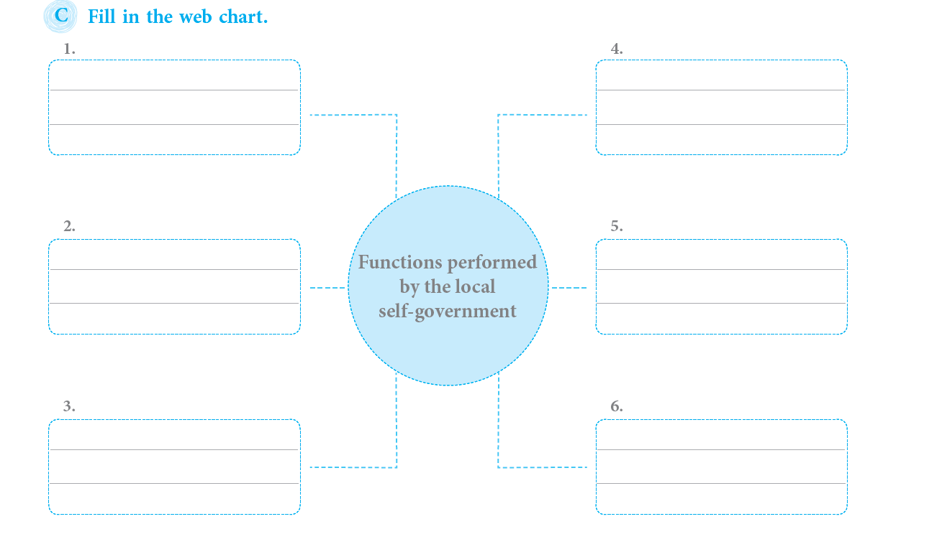

GRADE: IV NAME:
DATE: SUB: SOCIAL
WORKSHEET - 12
19. OUR CIVIC AMENITY

